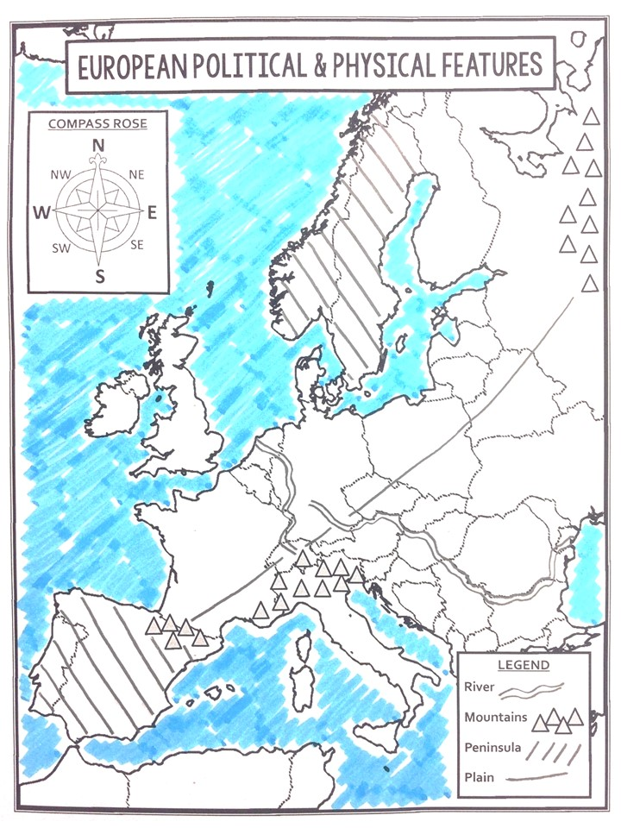

1

I

H

G

F

E

D

3

C

B

A

7

5

6

4

2

Directions: Correctly label each feature. Numbers 1-7 are political features, and letters A-I are physical features.

|  |  |  |  |
| --- | --- | --- | --- |
| France | Germany | Spain | Russia |
| United Kingdom | Italy | Ukraine |  |

1. United Kingdom
2. France
3. Spain
4. Germany
5. Ukraine
6. Russia
7. Italy

|  |  |  |
| --- | --- | --- |
| European Plain | Iberian Peninsula | English Channel |
| Mediterranean Sea | Rhine River | Danube River |
| Ural Mountains | Alps Mountains | Pyrenees Mountains |

1. Danube River
2. Rhine River
3. English Channel
4. Iberian Peninsula
5. Pyrenees Mountains
6. Alps Mountains
7. Ural Mountains
8. European Plain
9. Mediterranean Sea